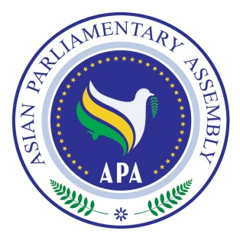
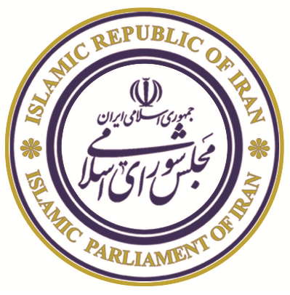
The Meeting of APA Standing Committee
on Political Affairs

25-28 June 2019

Isfahan, Islamic Republic of Iran

Draft Agenda

1- Adoption of the Agenda
2- Election of the Bureau
3- Opening Remarks by Chairperson
4- Report of APA Secretary General
5- Consideration of:

- Draft Resolution on Towards an Asian Parliament.
- Draft Resolution on Good Governance.
- Draft Resolution on Rule of Law and Judicial Empowerment.
- Draft Resolution on Good Parliamentary Practices.
- Draft Resolution on Building Prosperity in Asia through Friendship and Cooperation.
- Draft Resolution on Asian Parliaments and Governments Together for Prosperity in Asia.
- Draft Resolution on Asian Parliaments’ Unwavering Support for the Palestinian People.
- Draft Resolution on Harmonious Development through Democracy
- New Draft Resolution on Enhancing Cooperation among the Members of the Asian Parliamentary Assembly to Protect and Promote Multilateralism

6- Working Group on Asian Parliament
7- Any other matters
8- Closing Session

As of 19 June 2019

